**Name:** Safyan Anwar

**Roll no:** BSSE-24-018

**Assignment:** 4

**Section:** 3A-BSSE

**LAB # 4:**

**Task: “insert_at_middle”:-**

**Code:**

**// LAB # 4:**

**#include<iostream>**

**using namespace std;**

**class Node{**

**public:**

**int data;**

**Node* next;**

**Node(int data){**

**this-> data =data;**

**this-> next =NULL;**

**}**

**void insertATHead(Node* &head, int d){**

**Node* temp =new Node(d);**

**temp->next= head;**

**head= temp;**

**}**

**void insertATTail(Node* &tail, int d){**

**Node* temp =new Node(d);**

**tail->next=temp;**

**tail=temp;**

**}**

**void insertATPosition(Node* &head, int position, int d){**

**if(position==1){**

**insertATHead(head, d);**

**return;**

**}**

**Node* temp =head;**

**int cnt=1;**

**while(cnt<position-1){**

**temp=temp->next;**

**cnt++;**

**}**

**if(temp==NULL){**

**cout<<"invalid position"<<endl;**

**delete temp;**

**return;**

**}**

**Node* nodetoinsert= new Node(d);**

**nodetoinsert->next=temp->next;**

**temp->next=nodetoinsert;**

**}**

**void print(Node* head){**

**Node* temp =head;**

**while(temp!=NULL){**

**cout<<temp->data<<" ";**

**temp =temp->next;**

**}**

**cout<<endl;**

**}**

**};**

**int main(){**

**Node* node1 =new Node(10);**

**Node* head =node1;**

**Node* tail =node1;**

**node1->print(head);**

**node1->insertATTail(tail, 23);**

**node1->print(head);**

**node1->insertATTail(tail, 27);**

**node1->print(head);**

**node1-> insertATPosition(head, 1, 44);**

**node1-> print(head);**

**return 0;**

**}**

**Output:**

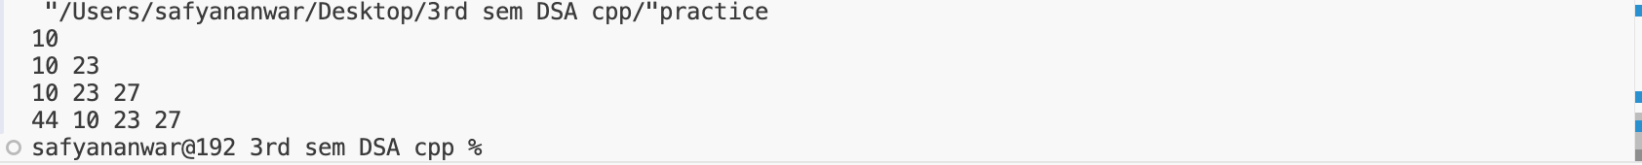

**Explanation:**

The ‘node’ class represents a node in linked list with the constructor to initialize the node data and next pointer. ‘insertATHead’ insert a new node at the head. ‘insertATTail’ insert a new node at the tail and updates the tail pointer. ‘insertATPosition’ insert a new node at a specified position. If the position is invalid it print "invalid position". And main function initialize a linked list with a single node value is 10. Inserts 23 and 27 at the tail and prints the list after each insertion. Inserts 44 at position 1 head and prints the list.